PARTNER RESOURCES:

30 Smokefree Days
For Public Health Professionals

30 Smokefree Days is a Facebook event hosted by the Centers for Disease Control and Prevention’s (CDC) Office on Smoking and Health (OSH) and the National Cancer Institute (NCI). This toolkit contains suggested social media messages and images as well as newsletter and blog text to share with your tobacco control partners or with others in your community who may be interested in quitting smoking.

Table of Contents

What is 30 Smokefree Days?........................ ................................... Page 1
When is it?........................................................................................Page 1
How can partners help?....................................................................Page 2
Facebook Messages ……………………………………………………Page 3
Twitter Messages.................................................……………………Page 5
Newsletter/Blog Text…...…...…...…...…...……...…………………… Page 6
Flyers/Handouts…...…...…...…...…...…...…...…...…...…...…...…... Page 8

What is 30 Smokefree Days?
30 Smokefree Days is a free 30-day quit smoking event held in Facebook for smokers who are thinking about quitting smoking, but would like some extra support along the way. It is also for the supporters of people trying to quit, or people who have already quit and would like to help support others. Starting July 10, Facebook users can join together to receive support such as links to quit resources, quit tips, encouragement, milestone badges, and exclusive video content with words of advice from Tips From Former Smokers® participants. In addition, there will be Facebook Live streaming video sessions where staff from NCI will cover specific topics relevant to cessation, provide guidance on successful quit skills, and answer smokers’ questions.

When is it?
The event runs from July 10-August 9, 2017, but you can start promoting right away.

How can public health professionals help?
You can support the event by sharing it with your tobacco control partners and with your community through your communication channels such as Facebook, Twitter and email/newsletters. Printable flyers included at the end of this toolkit can also be shared or posted in community centers, outreach clinics, and other places.

If you have any questions or need assistance, please contact Tessa Revolinski at TRevolinski@cdc.gov or Caryn Coln at CColn@cdc.gov.

Facebook Messaging Recommendations
30 Smokefree Days takes place entirely on Facebook, so sharing the event on Facebook is the most direct way to connect potential participants to the event.

To promote the event by sharing it on Facebook, follow the steps below. Once the link is included in your post, the message will automatically show an image, event dates, and way for a user to join.

Note: Users working inside a firewall may encounter difficulties copying and pasting text into Facebook. Possible workarounds include using an alternative browser, the Facebook app, or typing in the text manually.

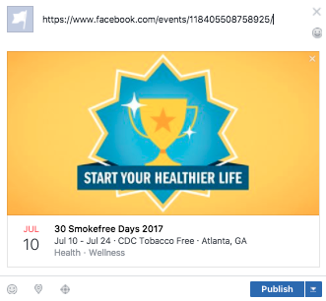

How to share the event on Facebook:
- Copy this link: https://www.facebook.com/events/118405508758925/
- Paste the link into the status box on Facebook
- Once the event populates the status box, delete the previously pasted URL link from the status box (the event invitation graphic should by now have appeared automatically beneath your status text--see screenshot, above for example—so the URL is no longer needed).
- Copy and paste one of these status text options where the URL was:

Audience | Status Text
Tobacco control partners | Help people in your community quit smoking by inviting them to join “30 Smokefree Days,” a 30-day quit smoking event providing a built-in community of people who want a healthier life. Participants get free access to mobile quit apps, tips, “quitspiration” posts, and video streams from experts to help them overcome challenges and meet their goal of becoming smokefree.
Smokers and supporters | Thinking of quitting smoking? Want some extra help? Join “30 Smokefree Days,” a 30-day quit smoking event providing a built-in community of people like you who want a healthier life! Get free access to mobile quit apps, tips, “quitspiration” posts, and video streams from experts to help you overcome challenges and meet your goal of becoming smokefree.

- Click Post/Publish.

Participants will need to have a Facebook profile to join the event. If they need to create a profile, this can be done at www.facebook.com

Other ways to support via Facebook
Supporters with Facebook accounts can also help promote the event by visiting https://www.facebook.com/events/118405508758925/ and clicking “Interested,” which will help the event show in their newsfeeds to people they have friended on Facebook.

Twitter Messaging Recommendations
While the event will take place on Facebook, we also suggest promoting it through Twitter and have provided suggested text and a Twitter-sized image.

How to share the event on Twitter:
- Save the Twitter image* to your local device.
*Image file 30-smokefree-days-twitter.jpg accompanied this document).
- Choose one of the tweets** below and paste them into the textbox on Twitter:
**There is a 140 character limit for tweets, including mentions and links. Images do not count toward the characters.

Audience | Tweet
Tobacco control partners | Invite your community to quit smoking July 10 for “30 Smokefree Days” on Facebook. @CDCTobaccoFree & @SmokefreeGov http://bit.ly/CDC30SFD
Smokers and supporters | Want help quitting smoking? Join us July 10 for “30 Smokefree Days” on Facebook. @CDCTobaccoFree & @SmokefreeGov http://bit.ly/CDC30SFD

- Click the image icon to add saved image from step 1.

- Click “Tweet.”

Twitter image looks like this:
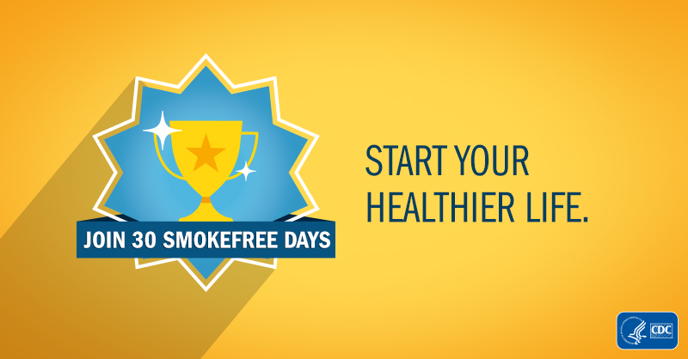

Newsletter and Blog Text Recommendations
This suggested text can be used in a newsletter, bulletin, or blog article highlighting the 30 Smokefree Days event.

Audience: Tobacco control partners for Newsletters, Blogs. Etc.
Headline | CDC, NCI Partner in July for 30 Smokefree Days Facebook Event
Short Copy (~90 words) | Help people in your community quit smoking by inviting them to join 30 Smokefree Days, a 30-day quit smoking event on Facebook for people wanting to build a healthier life. From July 10 to August 9, participants will get free access to mobile quit apps, tips, “quitspiration” posts, and video streams from experts to help them overcome challenges and meet their goal of becoming smokefree. RSVP at http://bit.ly/CDC30SFD. Event provided by the Centers for Disease Control and Prevention’s (CDC) Office on Smoking and Health (OSH) and the National Cancer Institute (NCI).
Long Copy (~160 Words) | Help people in your community quit smoking and live a healthier life! The Centers for Disease Control and Prevention’s (CDC) Office on Smoking and Health (OSH) and the National Cancer Institute (NCI) are partnering for 30 Smokefree Days, an online 30-day quit smoking event in Facebook for those thinking about quitting smoking, but who want some extra help.  Participants will get encouragement and support, plus free access to mobile quit apps, tips, “quitspiration” posts, milestone badges, and exclusive video content with words of advice from Tips From Former Smokers™ participants. In addition, there will be Facebook Live video streams where NCI experts will answer smokers’ questions and provide guidance on how to overcome common challenges that arise during a quit attempt.  The event is from July 10 to August 9, and Facebook users can RSVP starting June 26 at http://bit.ly/CDC30SFD.
Audience: Smokers and Supporters for Bulletins
Headline | Thinking of quitting smoking? Want some help? Join others for a 30-day event this July 10 on Facebook!
Short Copy (~90 words) | Join 30 Smokefree Days, a 30-day quit smoking event on Facebook providing a built-in community of people like you who want to live a healthier life! From July 10 to August 9, you’ll get free access to mobile quit apps, tips, “quitspiration” posts, and video streams from experts to help you overcome challenges and meet your goal of becoming smokefree. RSVP at http://bit.ly/CDC30SFD. Event provided by the Centers for Disease Control and Prevention’s (CDC) Office on Smoking and Health (OSH) and the National Cancer Institute (NCI).
Long Copy (~160 Words) | Join 30 Smokefree Days, a 30-day quit smoking event on Facebook providing a built-in community of people like you who want a healthier life!  The Centers for Disease Control and Prevention’s (CDC) Office on Smoking and Health (OSH) and the National Cancer Institute (NCI) invite you to join them an online 30-day quit smoking event in Facebook created for those thinking about quitting smoking, but who want some extra help.  You’ll get encouragement and support, plus free access to mobile quit apps, tips, “quitspiration” posts, milestone badges, and exclusive video content with words of advice from Tips From Former Smokers™ participants. In addition, there will be Facebook Live video streams where NCI experts will answer smokers’ questions and provide guidance on how to overcome common challenges that arise during a quit attempt.  The event is from July 10 to August 9, and Facebook users can RSVP starting June 26 at http://bit.ly/CDC30SFD.

Flyers/Handouts

Printable flyers in both color and black and white accompanied this toolkit (Adobe Acrobat PDF format).
- Black and White: 30-Smokefree-Days-Flyer-BW.pdf
- Color: 30-Smokefree-Days-Flyer-Color.pdf

Thumbnail examples of flyers:

