**Tobacco Control Resources**

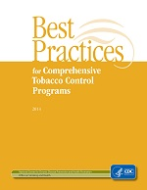**CDC - Best Practices for Comprehensive Tobacco Control Programs – 2014** (<http://www.cdc.gov/tobacco/stateandcommunity/best_practices/index.htm>)

This evidence-based guide helps states plan and establish effective tobacco control programs to prevent and reduce tobacco use. This document updates *Best Practices for Comprehensive Tobacco Control Programs—2007*. This updated edition describes an integrated programmatic structure for implementing interventions proven to be effective and provides levels of state investment to prevent and reduce tobacco use in each state.

**[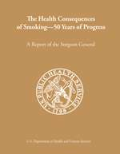](http://www.surgeongeneral.gov/library/reports/50-years-of-progress/full-report.pdf)2014 Surgeon General’s Report: The Health Consequence of Smoking – 50 Years of Progress** (<http://www.cdc.gov/tobacco/data_statistics/sgr/50th-anniversary/index.htm>)

This comprehensive report chronicles the devastating consequences of 50 years of tobacco use in the United States.

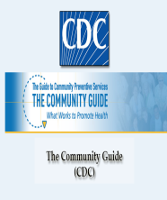**The Guide to Community Preventive Services: The Community Guide - What Works to Promote Health**

(<http://www.thecommunityguide.org/tobacco/index.html>)

The Community Guide is a resource to help practitioners and communities make informed, evidence-based decisions about what works to improve public health. Based on recommendations of the Task Force on Community Preventive Services, the Community Guide highlights public health interventions that have or have not been successful; identifies populations and settings where the interventions have or have not succeeded; explores potential costs and return on investment for the interventions; considers other potential benefits and harms the interventions may have; and examines other areas for potential research.

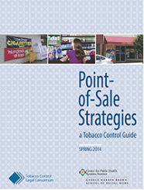 **Point-of-Sale Strategies Tobacco Control Guide – 2014**

([http://cphss.wustl.edu/Products/Documents/CPHSS_TCLC_2014_PointofSaleStrategies1.pdf?cm_mid=3329630&cm_crmid={9229b57b-d8d6-df11-b47f-00155d01644f}&cm_medium=email](http://cphss.wustl.edu/Products/Documents/CPHSS_TCLC_2014_PointofSaleStrategies1.pdf?cm_mid=3329630&cm_crmid=%7b9229b57b-d8d6-df11-b47f-00155d01644f%7d&cm_medium=email))

The guide content is based on current research and interviews with local, state, and national point-of-sale experts. The 52-page guide provides practical guidance on selecting and implementing strategies to limit the sale, display, and advertising of tobacco products in the retail environment.

[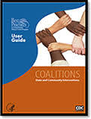](http://www.google.com/imgres?imgurl=http://ttac.org/services/Tobacco_101/images/slideshow/part2-4-coalitionsGuide.jpg&imgrefurl=http://ttac.org/services/Tobacco_101/mod2lesson4.html&h=199&w=152&tbnid=aEE-iEGUvn2oIM:&zoom=1&docid=2WPYaT34WcZkNM&ei=415EU9vUC-qd0AGX6oCgAQ&tbm=isch&ved=0CLACEIQcMEY&iact=rc&dur=865&page=2&start=43&ndsp=44)**CDC – Best Practices for Comprehensive Tobacco Control Programs: Coalitions- State and Community Interventions**

(<http://cphss.wustl.edu/Products/Documents/UG_Coalitions.pdf>)

The Centers for Disease Control and Prevention, Office on Smoking and Health and the Center for Tobacco Policy Research at Washington University in St. Louis developed a series of user guides for the State and Community Interventions Category for the *2007 Best Practices for Comprehensive Tobacco Control Programs* (*Best Practices*). A number of tobacco control focus areas including policy (e.g., coalitions, policy advocacy, economic pricing); youth (e.g., engagement and access); and disparities are addressed in the user guide series. [The purpose of the user guide series is to assist state and local tobacco control staff in building effective and sustainable comprehensive tobacco control programs. The user guides will address particular practices (](http://www.google.com/imgres?imgurl=http%3A%2F%2Fttac.org%2Fservices%2FTobacco_101%2Fimages%2Fslideshow%2Fpart2-4-coalitionsGuide.jpg&imgrefurl=http%3A%2F%2Fttac.org%2Fservices%2FTobacco_101%2Fmod2lesson4.html&h=199&w=152&tbnid=aEE-iEGUvn2oIM%3A&zoom=1&docid=2WPYaT34WcZkNM&ei=415EU9vUC-qd0AGX6oCgAQ&tbm=isch&ved=0CLACEIQcMEY&iact=rc&dur=865&page=2&start=43&ndsp=44)*[e.g.,](http://www.google.com/imgres?imgurl=http%3A%2F%2Fttac.org%2Fservices%2FTobacco_101%2Fimages%2Fslideshow%2Fpart2-4-coalitionsGuide.jpg&imgrefurl=http%3A%2F%2Fttac.org%2Fservices%2FTobacco_101%2Fmod2lesson4.html&h=199&w=152&tbnid=aEE-iEGUvn2oIM%3A&zoom=1&docid=2WPYaT34WcZkNM&ei=415EU9vUC-qd0AGX6oCgAQ&tbm=isch&ved=0CLACEIQcMEY&iact=rc&dur=865&page=2&start=43&ndsp=44)* [programs, interventions) that have evidence or potential evidence supporting their efficacy, and that fall under the coordination of state and local tobacco programs.](http://www.google.com/imgres?imgurl=http%3A%2F%2Fttac.org%2Fservices%2FTobacco_101%2Fimages%2Fslideshow%2Fpart2-4-coalitionsGuide.jpg&imgrefurl=http%3A%2F%2Fttac.org%2Fservices%2FTobacco_101%2Fmod2lesson4.html&h=199&w=152&tbnid=aEE-iEGUvn2oIM%3A&zoom=1&docid=2WPYaT34WcZkNM&ei=415EU9vUC-qd0AGX6oCgAQ&tbm=isch&ved=0CLACEIQcMEY&iact=rc&dur=865&page=2&start=43&ndsp=44)

**Division of Community Health -** **Practitioner's Guide for Advancing Health Equity** (<http://www.cdc.gov/nccdphp/dch/pdf/HealthEquityGuide.pdf>)

This resource guide is for practitioners, partners, and stakeholders working to advance health equity through community health interventions. While health disparities can be addressed at multiple levels, this guide focuses on policy, systems, and environmental improvements designed to improve the places where people live, learn, work, and play.

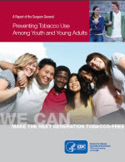**Preventing Tobacco Use Among Youth and Young Adults We CAN Make the Next Generation Tobacco Free (SGR 2012)**

(<http://www.surgeongeneral.gov/library/reports/preventing-youth-tobacco-use/index.html>)

In 2012, Surgeon General's report details important new information about tobacco use among youth and young adults, the causes, and the solutions.

[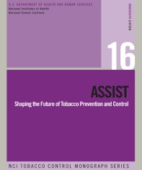](https://pubs.cancer.gov/ncipl/detail.aspx?prodid=T018#magnify)**National Cancer Institute: Monograph 16: ASSIST Shaping the Future of Tobacco Prevention and Control**

(<http://cancercontrol.cancer.gov/brp/tcrb/monographs/16/>)

The National Cancer Institute (NCI) presents the 16th monograph of the Tobacco Control Monograph series and a new design to facilitate readability. NCI remains strongly committed to furthering the science of tobacco prevention and control through the timely discussion of evidence-based research, emerging issues, and program and policy applications. By producing and disseminating the Tobacco Control Monographs, NCI seeks to increase the impact of tobacco control research and enhance the translation of research to practice and policy.

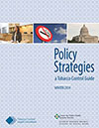

**Policy Strategies a Tobacco Control Guide- 2014**

(<http://publichealthlawcenter.org/sites/default/files/resources/tclc-guide-tobacco-policy-strategies-WashU-2014.pdf>)

This guide provides tobacco control program managers with guidance on the best ways to incorporate evidence-based policy strategies in a comprehensive program. According to Best Practices 2014, communities must work to transform the knowledge, attitudes, and practices of tobacco users and nonusers by changing the way tobacco is promoted, sold, and used. Advancing evidence-based policy strategies involves working with coalitions, the media, decision makers, business owners, and communities to create smoke-free environments, increase the cost of tobacco products, and restrict access to tobacco products. The development, implementation, and enforcement of such policies help make tobacco less affordable and protect kids by reducing initiation and promoting cessation.

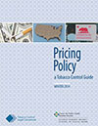**Pricing Policy a Tobacco Control Guide** **–2014** (<http://cphss.wustl.edu/Products/Documents/CPHSS_TCLC_2014_PricingPolicy1.pdf>)

This guide focuses on the role pricing policies can play as part of a comprehensive tobacco control program. Raising the cost of tobacco products is the single most effective method for decreasing smoking prevalence and initiation, reducing consumption, and encouraging cessation. Policies that effectively raise the cost of tobacco products include excise tax increases, non-tax price-related policies, and enforcement measures. Implementation of these policies reduces the social acceptability of tobacco use and strengthens the fight against pro-tobacco influences.

[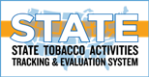](http://apps.nccd.cdc.gov/statesystem/Default/Default.aspx) **State Tobacco Activities Tracking and Evaluation (STATE) System**

(<http://apps.nccd.cdc.gov/statesystem/Default/Default.aspx>)

The STATE System is an interactive application that houses and displays current and historical state-level data on tobacco use prevention and control.

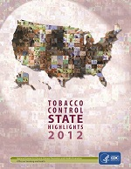 **Tobacco Control State Highlights 2012**

(<http://www.cdc.gov/tobacco/data_statistics/state_data/state_highlights/2012/index.htm>)

The purpose of Tobacco Control State Highlights 2012 is to provide tobacco control programs in the 50 states and the District of Columbia with state-specific valid and reliable data about the high-impact strategies they are currently or could be implementing and measures to track their progress.



**Tobacco Control Network Policy Platform**

(<http://www.ttac.org/tcn/materials/pdfs/TCN_Policy_Platform_2012.pdf>)

The TCN recommends all states and communities achieve science-based strategies to end the epidemic of tobacco use and address the needs of those populations that are disproportionately affected by the resulting toll it takes on individuals, families and communities.

[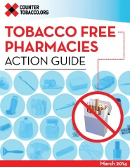](http://countertobacco.org/sites/default/files/CounterTobacco_PharmaciesActionGuide_FinalWeb.pdf)**Tobacco Free Pharmacy Action Guide**

(<http://countertobacco.org/tobacco-free-pharmacies>)

This action guide was developed in collaboration with tobacco control stakeholders across the country to help communities prohibit the sale of tobacco products in pharmacies. Despite the known health risks of tobacco, pharmacies represent nearly 5% of cigarette sales, and while cigarette sales declined nationally by 17%, from 2005-2009, cigarette sales *increased* in pharmacies by 23% during this time.The guide provides recommendations and tools to help tobacco control programs build support and develop a policy to prohibit the sale of tobacco products in pharmacies.