Honor Every Woman
Great Plains Breast and Cervical Cancer Early Detection Program (GP-BCCEDP)

Great Plains Breast and Cervical Cancer Early Detection Program
(GP-BC

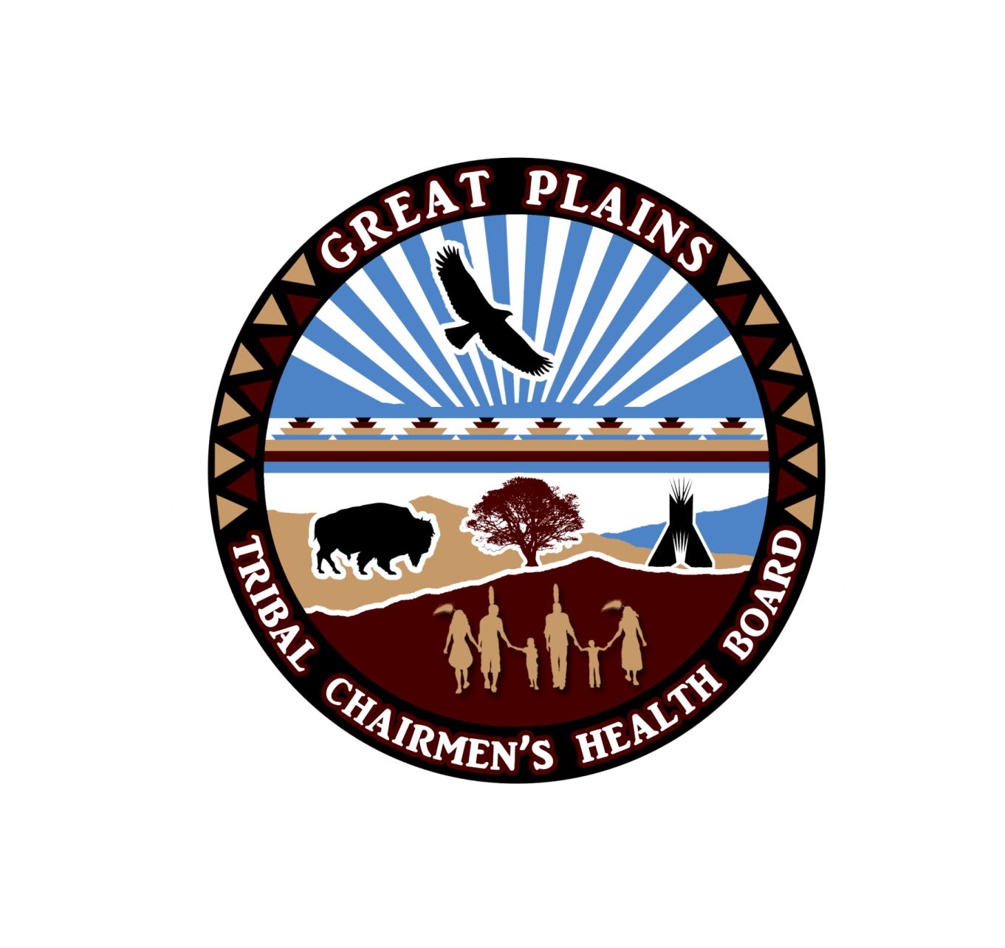

“So that the people may live”
2018/2019 community GRANT
fOR BCCEDP EVIDENCE BASED INterventionS

2611 Elderberry Blvd., Rapid City, SD 57703—(P) 605.721.1922—(F) 605.721.1932—www.gptchb.org

Community Contract: Increasing Breast and Cervical Cancer Screening through Evidence- based Interventions

Community Grant: Increasing Breast and Cervical Cancer Screening using Evidence-Based Interventions
The Honor Every Woman Regional Cancer Screening Grant provides support for increasing population-based breast and cervical cancer screening rates within partner health systems through the implementation of evidence- based interventions. Up to six clinics or community programs within the four-state region of North Dakota, South Dakota, Nebraska, and Iowa will be awarded up to $10,000.00 to increase population based breast and cervical cancer screening rates by incorporating screening interventions within tribal communities. Sub-awardees will implement changes in current screening practices through evidence- based interventions (EBI’s) and health systems changes that address breast and cervical cancer screening rates. Sub-awardees will implement community-clinical linkages with EBI’s that contribute to breast and cervical cancer screening, cancer prevention, early detection, and patient navigation.
The Honor Every Woman Program is looking for community partners (e.g. clinics, tribal health, or programs within the community) to take on this funding using especially creative approaches to increase breast and cervical cancer screening demand and rates in their service areas. Applications that put community members and community resources at the forefront of their plans to increase breast and cervical cancer screening will be considered highly desirable.
Grant Application Timeline
July 11 | July 24 | August 10 | August 17 | September 24-28 | October1-June 1 | June 15
Application Opens |  | Grant Application Technical Assistance Webinar |  | Applications for Funding due by COB |  | Awards Announced |  | Onboarding/ Implementation Planning Webinars |  | Projects Begin |  | Final Report Due

Sub-Awardee Responsibilities
- Policy Adherence
  - Sub- awardees will follow the Honor Every Woman (GP-BCCEDP) Program Manual. This ensures a uniform approach to:
      - Evaluation, tracking, data management, and screening practices
  - Choose projects from the list of evidence- based interventions (EBI) that are listed in the application. Choose two EBI’s to implement.
- Reporting Requirements
  - Awardees must select two of the four EBI’s.
  - Awardees must complete a final 2-3 page report by June 15th, 2019 that includes a project abstract, the final project outcome, and final budget.
  - Awardees must participate in evaluation activities that consist of surveys and an annual interview with ACET, the evaluator that may conduct a short 15-minute interview.
  - Must report baseline screening rates at the beginning of the project and at the end of the project.
- Quality Improvement Initiatives
  - All awardees must create one quality improvement objective and identify it in their application.
  - These initiatives must concentrate on ensuring that the clinic or community program’s breast and cervical cancer screening efforts are focused on continual improvement in at least one aspect of program implementation.
- Program Communication- Requirements
  - Upon Notice of Award Honor Every Woman will schedule a technical assistance webinar with the sub-awardee; this webinar will be required for individuals working on the project. This webinar will cover project implementation planning with other pertinent project information.
  - Check in Calls - An individual from Honor Every Woman will call the sub- awardee to check in and receive updates on progress, hear issues, and to help plan the agenda for the quarterly conference call. Sub- awardee will determine frequency and timing of calls to provide updates, screening numbers, and barriers/ challenges.
  - Collaboration
    - Sub-awardees will ensure that avenues of communication between Tribal Health, Clinic Staff, and the Honor Every Woman program are open.
    - Through these avenues of communication Honor Every Woman, Tribal Health and Clinic Staff will be able to leverage the resources and knowledge available through regional, local, and clinical connections to use community resources to identify women who are of screening age.

Community Grant Application
for
Increasing Breast and Cervical
Cancer Screening through
Evidence- Based Interventions

Application Instructions
Applicant Qualifications
Tribes, tribal agencies, urban tribal programs, tribal non-profit organizations and other non-profit organizations serving American Indians in the Great Plains region (North Dakota, South Dakota, Nebraska, and Iowa) may apply. Organizations that apply may use a fiscal agent, if needed.
Restrictions
- Contracts will only be accepted from U.S. federally tax-exempt organizations; e.g. non-profit organizations, educational institutions, government agencies, and Indian tribes.
- Project activities must occur within the Great Plains region (North Dakota, South Dakota, Nebraska, and Iowa).
- Total budget must include direct and indirect costs.
- All equipment purchased with project funds must be used exclusively on this project during the project period. Equipment costs cannot exceed 30% of the direct costs.
- Salaries, if requested, are restricted to project activities.
- PROJECT FUNDS CANNOT BE USED TO PAY FOR TREATMENT SERVICES.

Process
- Applicants may request up to $10,000 dollars. The total number of grants awarded and the final amounts are dependent on the availability of funds.
- Applications are due Friday, August 10, 2018 by close of business 5PM MT. Please send completed application to
Tinka Duran, Community Health Prevention Director
2611 Elderberry Blvd
Rapid City, SD 57703
Phone: 605-721-1922
FAX: 605-721-2876
Email: tinka.duran@gptchb.org
- An e-mail will be sent to the primary contact e-mail address within one week of receipt (or fax, if no e-mail is provided). If you do not receive a confirmation within 1 week, please contact Tinka Duran (contact info above).
- Awards will be announced on August 17, 2018, projects begin October 1, 2018, and projects end June 1, 2019. A final report must be submitted by June 15, 2019. Failure to submit a report will result in forfeiture of opportunity to apply for future funding from the Honor Ever Woman Program.

Application Rubric and Scoring
Overall Project Design | 5 pts (12%) | Budget | 5 pts (12%)
Goals and Objectives | 10 pts (25%) | Patient Navigation
Project Plan | 15 pts (37%) | Total Points available | 40 pts
Partners and Stakeholders | 5 pts (12%)
Application for Community Grant

Point of contact
Name of Organization
Address |  |  |  |  |  | City, State
Primary Contact Name
Job Title |  |  |  |  |  | Fax Number
Phone Number |  |  |  |  |  | E-mail
List all satellite clinics |  |  | Name of Clinic |  |  | Location (city, State) |  |  | Phone Number
(If applicable)
PROJECT GOAL: Provide a broad statement of what you would like to achieve over the nine month project period.
PROJECT OBJECTIVES/PROJECT PLAN: List three specific objectives that you wish to accomplish over the project period. (Be sure to include: time lines, realistic goals, how you will partner, etc.).
1.
2.
3. | This objective should be focused on quality improvement efforts.
EVIDENCE- BASED INTERVENTIONS: Select two EBI’s to implement over the project period.

☐ |  | Provider assessment and feedback  Provider assessment and feedback interventions both evaluate provider performance in delivering or offering screening to clients (assessment) and present providers with information about their performance in providing screening performance (feedback).  Describe below how you will implement this evidence-based intervention (what staff and resources are needed):
☐ |  | Provider reminder and recall systems  Provider Reminder and Recall Systems inform health care providers it is time for a client’s cancer screening test (called a “reminder”) or that the client is overdue for screening (called a “recall”).  Describe below how you will implement this evidence-based intervention (what staff and resources are needed):
☐ |  | Client reminders  Client reminders are written (letter, postcard, email) or telephone messages (including automated messages) advising people that they are due for screening.  Describe below how you will implement this evidence-based intervention (what staff and resources are needed):
☐ |  | Reducing structural barriers  Reducing structural barriers as non-economic burdens or obstacles, which make it difficult for people to access cancer screening (e.g., gas cards).  Describe below how you will implement this evidence-based intervention (what staff and resources are needed):

PrOJECT BUDGET
Total Amount Requested $
Personnel/Staff Time |  |  |  | Amount Requested |  |  |  | Justification
 |  |  |  | Amount $
 |  |  |  | Amount $
 |  |  |  | Amount $
Educational Materials |  |  |  | Amount Requested
 |  |  |  | Amount $
 |  |  |  | Amount $
 |  |  |  | Amount $
EBI Implementation |  |  |  | Amount Requested
 |  |  |  | Amount $
 |  |  |  | Amount $
 |  |  |  | Amount $
Other |  |  |  | Amount Requested
 |  |  |  | Amount $
 |  |  |  | Amount $
 |  |  |  | Amount $

ProJect EVALUATION
Briefly describe the data that you will collect and analyze to ensure your goals and objectives are being met, and indicate what methods you will use to collect this data.
Data Type |  |  |  |  |  |  | Collection Method
CAPACITY STATEMENT: Please write a statement on your organization’s capacity to carry out this project.
Primary Contact (Print Name) |  | Signature |  | Date

