Pre-Dental Gateway Program
Native American
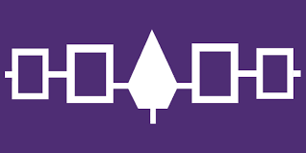
June 24th – June 28th 2019

Buffalo, New York

DID YOU KNOW?

Native Americans comprise only 0.2% of all dental school applications while Native Americans as a whole represent 2% of the U.S. population—clearly an underrepresentation in Dentistry.

To Build a More Inclusive Profession

University at Buffalo School of Dental Medicine and Seneca Nation Health System offer
an immersive five-day Native American Pre-Dental Gateway Program.

Participants get an in-depth look at Dental education and…

Hands on clinical techniques Preclinical laboratory procedures
Introduction to dental specialties Career Conversations
Financial aid projections Admissions process & counseling

Ideal for anyone considering applying to dental school
(Native American students/recent graduates and Native I.H.S./Tribal Dental Staff)

http://dental.buffalo.edu/community-outreach/Summer2019GatewayProgram.html
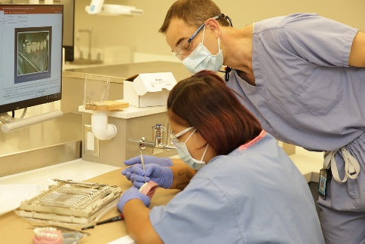
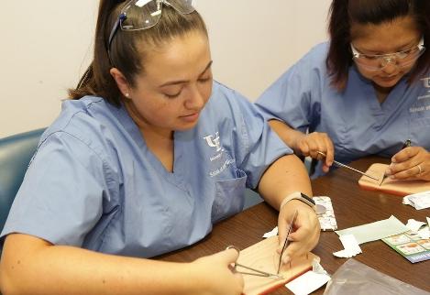

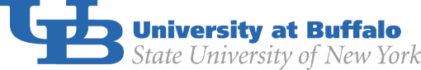

Contact: jsalamon@senecahealth.org or 716-532-5582 x5264

